Joel Atkinson
February 7, 2026
CSD430 Server Side Development
Assignment 5&6-1
Below are the screenshots of me setting up and populating my CSD430 database with the Joel_states_data table to give the table all of the data that will be pulled and displayed through my bean and jsp files.
Note: This assignment took me many days of playing around with things and changing things because of mistakes as well as just to improve the overall product. I started by having my drop down on selectState.jsp be just the ID number since that was the primary key I set up while making the database, however, I quickly realized that made no sense because I entered the States in a completely random order with no rhyme or reason. Because of this I decided to change the drop down to now list the name of the state, and I also added in the year founded as an additional data column to add some extra data and detail. This was definitely a difficult assignment with creating the database and table in SQL, creating the index.jsp, the JavaBean, the selectState.jsp, and the displayState.jsp, in addition to styling them all with .css files. I finally got it all to work the way I wanted though and am quite happy with the outcome.

Creating the database and user:
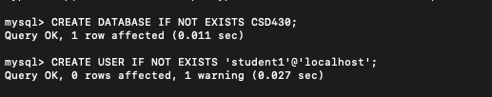

Creating the table (first called it states_data before realizing it needed to be Joel_states_data)
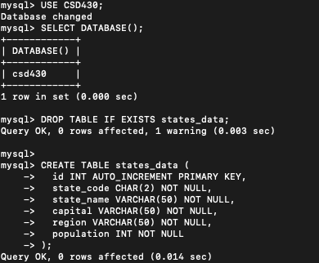

Changing the name of table:
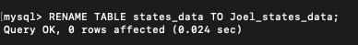

Adding data to the table:
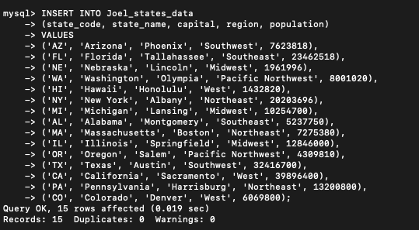
Adding in the year founded column and the data for each state after playing around with it and realizing I wanted to add another data column:
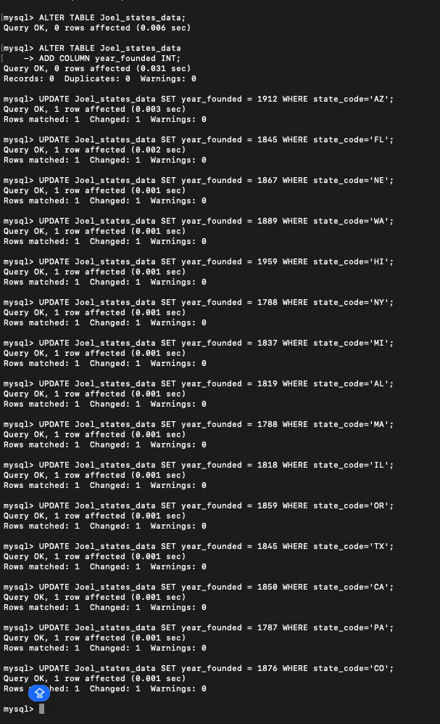

Table data displayed in order of State name instead of ID.
